LEBRON SOLDIER XII SFG

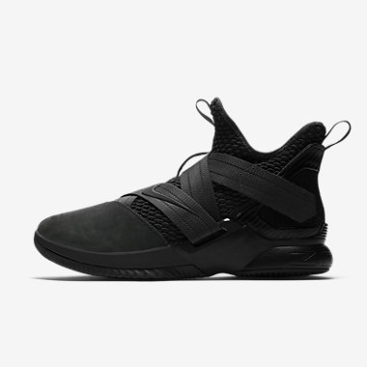

Product code: 1001

Nike

The LeBron Soldier XII SFG Basketball Shoe delivers lightweight, responsive cushioning for the court with Nike Zoom Air cushioning. Adjustable hook-and-loop straps offer adjustable, secure lockdown.

# Kyrie 4

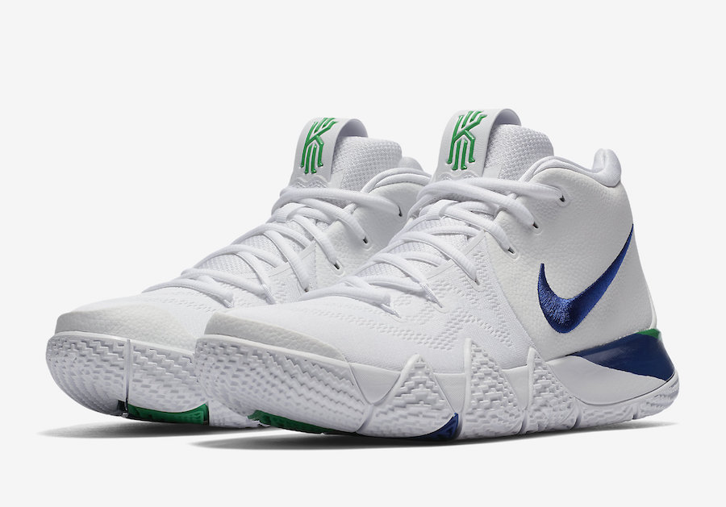

Product code: 1002

Nike

The Kyrie 4 Men's Basketball Shoe is ultra-flexible, responsive and supportive. It's designed for Kyrie Irving's sudden changes of direction and smooth yet rapid playing style.

# Jordan Ultra Fly 2 Low

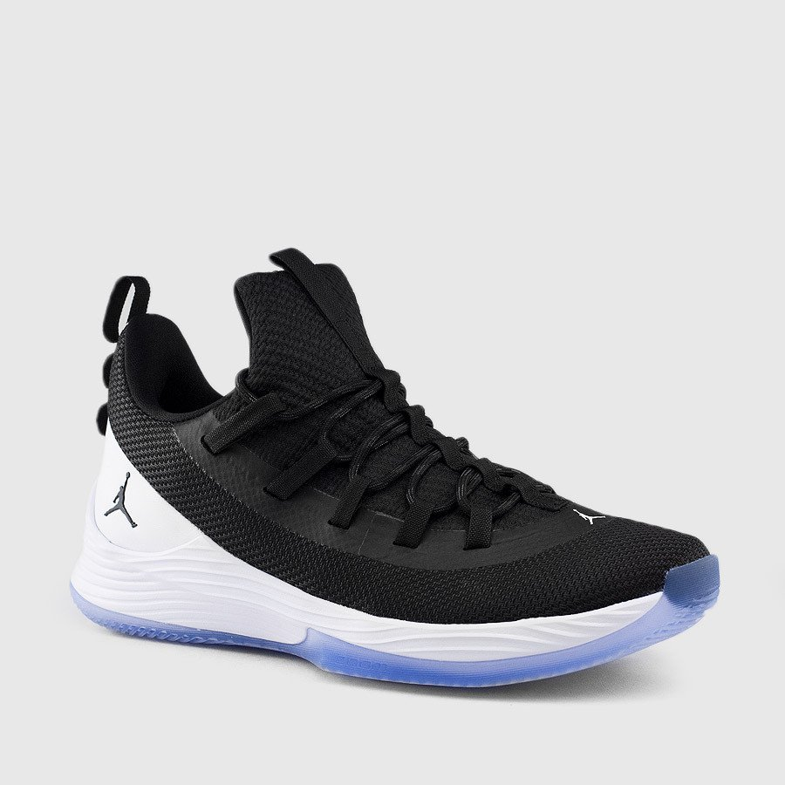

Product code: 1003

Nike

Designed for the versatile player who can play any position, the Jordan Ultra Fly 2 Low Men's Basketball Shoe offers responsive cushioning and lightweight lockdown.

# Nike Kobe A.D. Black Mamba

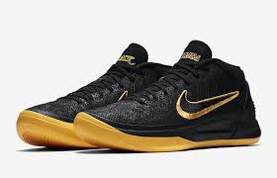

Product code: 1004

Nike

The Kobe A.D. Basketball Shoe delivers lightweight support, responsive cushioning and excellent traction during practice and on game day to help you push past your potential.

# Nike Air Max Dominate

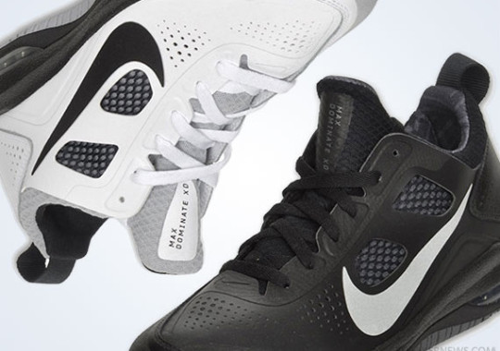

Product code: 1005

Nike

The Nike Air Max Dominate Men's Basketball Shoe offers breathable support and plush cushioning for dynamic movement on the court.